- SMART CITY AIR QUALITY MONITORING

# Install packages (Run only once)
install.packages("ggplot2")
install.packages("viridis")

# Load libraries
library(ggplot2)
library(viridis)

# Load built-in dataset
data("airquality")

# View dataset
head(airquality)
View(airquality)

# Remove missing values
air <- na.omit(airquality)

#==========================================================
# 1. Cartesian Coordinate Plot
#==========================================================

ggplot(air,
aes(x = Temp,
y = Ozone)) +
geom_point(size = 3, color = "blue") +
labs(
title = "Cartesian Coordinate System",
x = "Temperature (°F)",
y = "Ozone"
) +
theme_minimal()

#==========================================================
# 2. Sequential Color Scale
#==========================================================

ggplot(air,
aes(x = Temp,
y = Ozone,
color = Ozone)) +
geom_point(size = 4) +
scale_color_viridis_c() +
labs(
title = "Sequential Color Scale",
x = "Temperature",
y = "Ozone",
color = "Ozone"
) +
theme_minimal()

#==========================================================
# 3. Diverging Color Scale
#==========================================================

ggplot(air,
aes(x = Temp,
y = Ozone,
color = Ozone)) +
geom_point(size = 4) +
scale_color_gradient2(
low = "blue",
mid = "yellow",
high = "red",
midpoint = median(air$Ozone)
) +
labs(
title = "Diverging Color Scale",
x = "Temperature",
y = "Ozone",
color = "Ozone"
) +
theme_minimal()

#==========================================================
# 4. Qualitative Color Palette
#==========================================================

ggplot(air,
aes(x = Temp,
y = Ozone,
color = factor(Month))) +
geom_point(size = 4) +
labs(
title = "Qualitative Color Palette",
x = "Temperature",
y = "Ozone",
color = "Month"
) +
theme_minimal()

#==========================================================
# 5. Highlight Pollution Hotspots
#==========================================================

air$Pollution <- ifelse(air$Ozone > 80,
"High Pollution",
"Normal")

ggplot(air,
aes(x = Temp,
y = Ozone,
color = Pollution)) +
geom_point(size = 4) +
scale_color_manual(values = c(
"High Pollution" = "red",
"Normal" = "green"
)) +
labs(
title = "Highlighting Pollution Hotspots",
x = "Temperature",
y = "Ozone"
) +
theme_minimal()

OUTPUT:
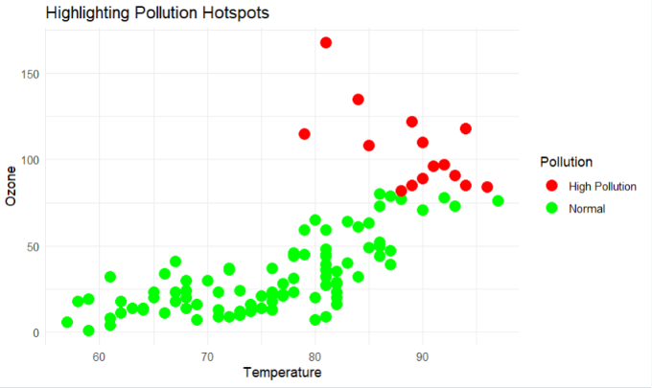

2.EARTHQUAKE RISK ANALYSIS

# Load library
library(ggplot2)

# Load built-in dataset
data("quakes")

# View dataset
head(quakes)
View(quakes)
#==========================================================
# 1. Linear Scale Scatter Plot
#==========================================================

ggplot(quakes,
aes(x = depth,
y = mag)) +
geom_point(color = "blue", size = 3, alpha = 0.7) +
labs(
title = "Earthquake Magnitude vs Depth (Linear Scale)",
x = "Depth (km)",
y = "Magnitude"
) +
theme_minimal()

#==========================================================
# 2. Nonlinear (Log) Scale Scatter Plot
#==========================================================

ggplot(quakes,
aes(x = depth,
y = mag)) +
geom_point(color = "red", size = 3, alpha = 0.7) +
scale_x_log10() +
labs(
title = "Earthquake Magnitude vs Depth (Log Scale)",
x = "Depth (Log Scale)",
y = "Magnitude"
) +
theme_minimal()

#==========================================================
# 3. Compare Depth Distribution
#==========================================================

ggplot(quakes,
aes(x = depth)) +
geom_histogram(fill = "steelblue",
color = "black",
bins = 30) +
labs(
title = "Earthquake Depth Distribution (Linear Scale)",
x = "Depth",
y = "Frequency"
) +
theme_minimal()

#==========================================================
# 4. Histogram with Log Scale
#==========================================================

ggplot(quakes,
aes(x = depth)) +
geom_histogram(fill = "orange",
color = "black",
bins = 30) +
scale_x_log10() +
labs(
title = "Earthquake Depth Distribution (Log Scale)",
x = "Depth (Log Scale)",
y = "Frequency"
) +
theme_minimal()

OUTPUT:
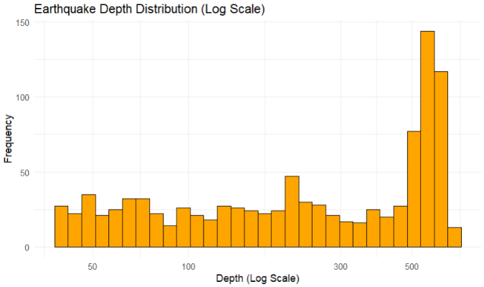
3.Wind Direction Analysis for Airport Operations

# Load library
library(ggplot2)

# Create Sample Dataset
wind <- data.frame(
Direction = c("N","NE","E","SE","S","SW","W","NW"),
WindSpeed = c(18,24,15,20,12,28,22,16)
)

# View Dataset
wind
View(wind)

#==========================================================
# 1. Cartesian Bar Chart
#==========================================================

ggplot(wind,
aes(x = Direction,
y = WindSpeed,
fill = Direction)) +
geom_bar(stat = "identity") +
labs(
title = "Wind Speed by Direction (Cartesian Plot)",
x = "Wind Direction",
y = "Wind Speed (km/h)"
) +
theme_minimal()

#==========================================================
# 2. Polar Coordinate (Wind Rose)
#==========================================================

ggplot(wind,
aes(x = Direction,
y = WindSpeed,
fill = Direction)) +
geom_bar(stat = "identity",
width = 1) +
coord_polar() +
labs(
title = "Wind Rose (Polar Coordinate)"
) +
theme_minimal()

OUTPUT:
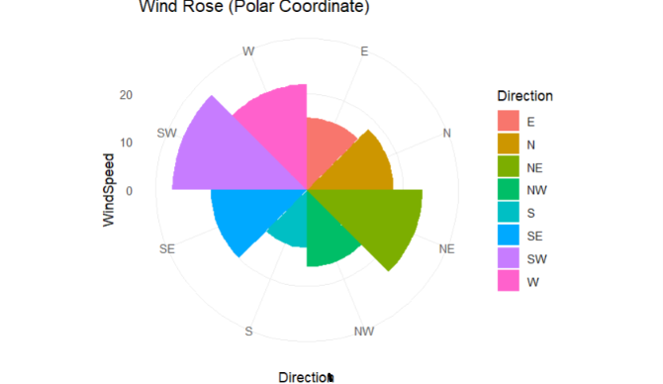

4.Hospital Patient Monitoring Dashboard

# Install packages (Run only once)
# install.packages("ggplot2")
# install.packages("dplyr")
# install.packages("patchwork")

library(ggplot2)
library(dplyr)
library(patchwork)

# -------------------------------
# Create Sample ICU Patient Data
# -------------------------------

set.seed(123)

n <- 60 # 60 minutes

icu <- data.frame(
Minute = 1:n,
HeartRate = round(rnorm(n, 85, 20)),
Oxygen = round(rnorm(n, 95, 3)),
SystolicBP = round(rnorm(n, 120, 20)),
Respiration = round(rnorm(n, 18, 5)),
Temperature = round(rnorm(n, 37, 0.7),1)
)

# -----------------------------------
# Introduce Some Abnormal Readings
# -----------------------------------

icu$HeartRate[c(10,25,50)] <- c(45,140,155)
icu$Oxygen[c(15,40)] <- c(85,82)
icu$SystolicBP[c(20,35)] <- c(170,85)
icu$Respiration[c(30,55)] <- c(32,8)
icu$Temperature[c(12,45)] <- c(39.5,35.2)

# -----------------------------------
# Heart Rate Status
# -----------------------------------

icu$HR_Status <- ifelse(
icu$HeartRate < 60 | icu$HeartRate > 100,
"Abnormal",
"Normal"
)

# -----------------------------------
# Oxygen Status
# -----------------------------------

icu$O2_Status <- ifelse(
icu$Oxygen < 90,
"Critical",
"Normal"
)

# -----------------------------------
# Blood Pressure Status
# -----------------------------------

icu$BP_Status <- ifelse(
icu$SystolicBP < 90 | icu$SystolicBP > 140,
"Abnormal",
"Normal"
)

# -----------------------------------
# Respiration Status
# -----------------------------------

icu$Resp_Status <- ifelse(
icu$Respiration < 12 | icu$Respiration > 20,
"Abnormal",
"Normal"
)

# -----------------------------------
# Temperature Status
# -----------------------------------

icu$Temp_Status <- ifelse(
icu$Temperature < 36 | icu$Temperature > 38,
"Abnormal",
"Normal"
)

# ==========================
# Heart Rate Plot
# ==========================

p1 <- ggplot(icu,
aes(Minute, HeartRate, color=HR_Status)) +
geom_line(size=1) +
geom_point(size=3) +
geom_hline(yintercept=c(60,100),
linetype="dashed",
color="blue") +
scale_color_manual(values=c(
Normal="darkgreen",
Abnormal="red")) +
labs(title="Heart Rate",
y="BPM") +
theme_minimal()

# ==========================
# Oxygen Plot
# ==========================

p2 <- ggplot(icu,
aes(Minute, Oxygen, color=O2_Status)) +
geom_line(size=1) +
geom_point(size=3) +
geom_hline(yintercept=90,
linetype="dashed",
color="blue") +
scale_color_manual(values=c(
Normal="darkgreen",
Critical="red")) +
labs(title="Oxygen Saturation",
y="SpO2 (%)") +
theme_minimal()

# ==========================
# Blood Pressure Plot
# ==========================

p3 <- ggplot(icu,
aes(Minute, SystolicBP,
color=BP_Status)) +
geom_line(size=1) +
geom_point(size=3) +
geom_hline(yintercept=c(90,140),
linetype="dashed",
color="blue") +
scale_color_manual(values=c(
Normal="darkgreen",
Abnormal="red")) +
labs(title="Blood Pressure",
y="mmHg") +
theme_minimal()

# ==========================
# Respiration Plot
# ==========================

p4 <- ggplot(icu,
aes(Minute, Respiration,
color=Resp_Status)) +
geom_line(size=1) +
geom_point(size=3) +
geom_hline(yintercept=c(12,20),
linetype="dashed",
color="blue") +
scale_color_manual(values=c(
Normal="darkgreen",
Abnormal="red")) +
labs(title="Respiration Rate",
y="Breaths/min") +
theme_minimal()

# ==========================
# Temperature Plot
# ==========================

p5 <- ggplot(icu,
aes(Minute, Temperature,
color=Temp_Status)) +
geom_line(size=1) +
geom_point(size=3) +
geom_hline(yintercept=c(36,38),
linetype="dashed",
color="blue") +
scale_color_manual(values=c(
Normal="darkgreen",
Abnormal="red")) +
labs(title="Temperature",
y="°C") +
theme_minimal()

# ==========================
# Dashboard
# ==========================

(p1 | p2) /
(p3 | p4) /
p5

OUTPUT:
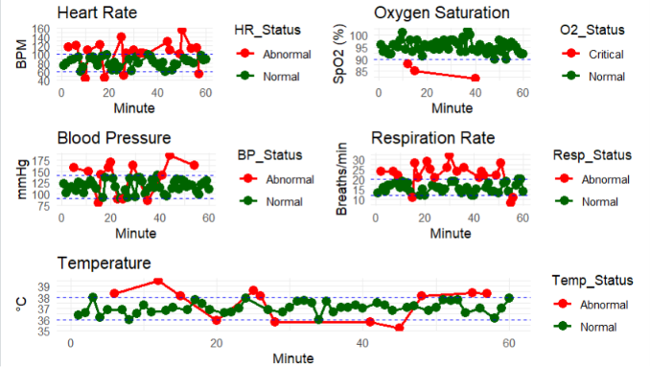
5. Global Climate Change Study - Heatmap

# Install packages (Run only once)
# install.packages("ggplot2")
# install.packages("RColorBrewer")
# install.packages("viridis")

library(ggplot2)
library(RColorBrewer)
library(viridis)

# Create Sample Dataset

set.seed(123)

countries <- paste("Country", 1:180)
years <- 1980:2025

climate <- expand.grid(
Country = countries,
Year = years
)

# Temperature anomaly values (-3°C to +3°C)
climate$Anomaly <- round(rnorm(nrow(climate), 0, 1), 2)

# =====================================
# Heatmap 1 - Blue-White-Red Palette
# =====================================

p1 <- ggplot(climate,
aes(x = Year,
y = Country,
fill = Anomaly)) +
geom_tile() +
scale_fill_gradient2(
low = "blue",
mid = "white",
high = "red",
midpoint = 0
) +
labs(
title = "Heatmap - Blue White Red",
fill = "Temp\nAnomaly"
) +
theme_minimal() +
theme(
axis.text.y = element_blank(),
axis.ticks.y = element_blank()
)

print(p1)

# =====================================
# Heatmap 2 - Spectral Palette
# =====================================

p2 <- ggplot(climate,
aes(x = Year,
y = Country,
fill = Anomaly)) +
geom_tile() +
scale_fill_distiller(
palette = "Spectral",
direction = -1
) +
labs(
title = "Heatmap - Spectral Palette",
fill = "Temp\nAnomaly"
) +
theme_minimal() +
theme(
axis.text.y = element_blank(),
axis.ticks.y = element_blank()
)

print(p2)

# =====================================
# Heatmap 3 - RdYlBu Palette
# =====================================

p3 <- ggplot(climate,
aes(x = Year,
y = Country,
fill = Anomaly)) +
geom_tile() +
scale_fill_distiller(
palette = "RdYlBu",
direction = -1
) +
labs(
title = "Heatmap - RdYlBu Palette",
fill = "Temp\nAnomaly"
) +
theme_minimal() +
theme(
axis.text.y = element_blank(),
axis.ticks.y = element_blank()
)

print(p3)

OUTPUT:

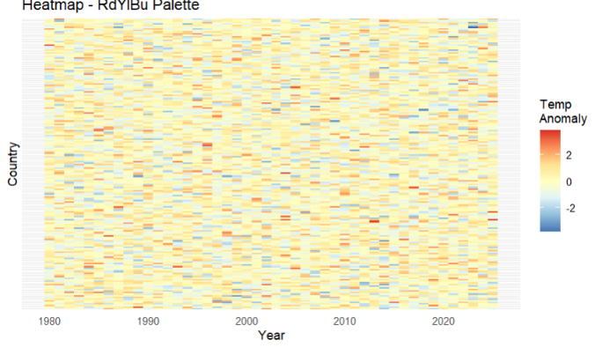

- E-Commerce Sales Analytics

# Install packages (Run only once)
# install.packages("ggplot2")
# install.packages("viridis")

library(ggplot2)
library(viridis)

# -----------------------------------------
# Create Sample Dataset
# -----------------------------------------

set.seed(123)

categories <- paste("Category", 1:50)
regions <- paste("Region", 1:30)

sales <- expand.grid(
Category = categories,
Region = regions
)

sales$Sales <- sample(1000:100000, nrow(sales), replace = TRUE)

# -----------------------------------------
# Visualization 1: Heatmap
# Quantitative Color Encoding
# -----------------------------------------

p1 <- ggplot(sales,
aes(x = Region,
y = Category,
fill = Sales)) +
geom_tile(color = "white") +
scale_fill_viridis(option = "C") +
labs(
title = "Sales Volume by Category and Region",
x = "Region",
y = "Category",
fill = "Sales"
) +
theme_minimal() +
theme(
axis.text.x = element_text(angle = 90),
axis.text.y = element_blank(),
axis.ticks.y = element_blank()
)

print(p1)

# -----------------------------------------
# Visualization 2: Bar Chart
# Qualitative Color Encoding
# -----------------------------------------

category_sales <- aggregate(Sales ~ Category,
data = sales,
sum)

p2 <- ggplot(category_sales,
aes(x = reorder(Category, Sales),
y = Sales,
fill = Category)) +
geom_bar(stat = "identity") +
coord_flip() +
labs(
title = "Total Sales by Product Category",
x = "Category",
y = "Total Sales"
) +
theme_minimal() +
theme(
legend.position = "none"
)

print(p2)

# -----------------------------------------
# Visualization 3: Bubble Chart
# Color + Size Represent Sales
# -----------------------------------------

sample_data <- sales[sample(nrow(sales), 250), ]

p3 <- ggplot(sample_data,
aes(x = Region,
y = Category,
size = Sales,
color = Sales)) +
geom_point(alpha = 0.7) +
scale_color_viridis() +
labs(
title = "Sales Distribution",
x = "Region",
y = "Category",
color = "Sales",
size = "Sales"
) +
theme_minimal() +
theme(
axis.text.x = element_text(angle = 90),
axis.text.y = element_blank(),
axis.ticks.y = element_blank()
)

print(p3)

OUTPUT:

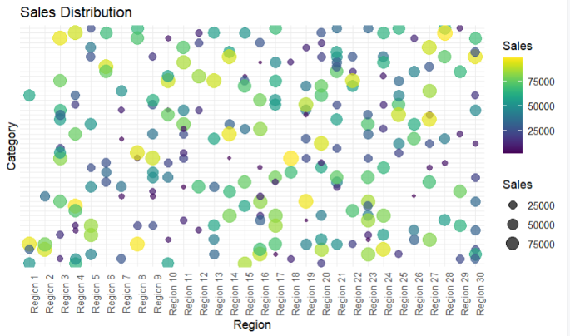

7. Satellite Image Vegetation Analysis

# Install packages (Run only once)
# install.packages("ggplot2")
# install.packages("viridis")
# install.packages("RColorBrewer")

library(ggplot2)
library(viridis)
library(RColorBrewer)

# --------------------------------------------
# Create Sample NDVI Dataset
# --------------------------------------------

set.seed(123)

rows <- 100
cols <- 100

ndvi <- expand.grid(
X = 1:rows,
Y = 1:cols
)

# NDVI values between -1 and +1
ndvi$NDVI <- round(runif(nrow(ndvi), -1, 1), 2)

# ============================================
# Heatmap 1 - Sequential Green Palette
# ============================================

p1 <- ggplot(ndvi, aes(X, Y, fill = NDVI)) +
geom_tile() +
scale_fill_gradient(
low = "lightyellow",
high = "darkgreen"
) +
labs(
title = "Sequential Palette (Vegetation)",
fill = "NDVI"
) +
theme_minimal()

print(p1)

# ============================================
# Heatmap 2 - Diverging Blue-White-Green
# ============================================

p2 <- ggplot(ndvi, aes(X, Y, fill = NDVI)) +
geom_tile() +
scale_fill_gradient2(
low = "blue",
mid = "white",
high = "darkgreen",
midpoint = 0
) +
labs(
title = "Diverging Palette (Water-Vegetation)",
fill = "NDVI"
) +
theme_minimal()

print(p2)

# ============================================
# Heatmap 3 - Viridis Palette
# ============================================

p3 <- ggplot(ndvi, aes(X, Y, fill = NDVI)) +
geom_tile() +
scale_fill_viridis(
option = "D"
) +
labs(
title = "Viridis Palette",
fill = "NDVI"
) +
theme_minimal()

print(p3)

OUTPUT:
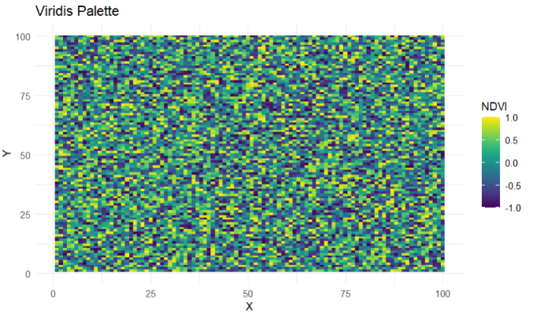

8. Cryptocurrency Market Volatility Analysis

# Install packages (Run only once)
# install.packages("ggplot2")

library(ggplot2)

# --------------------------------------------
# Create Sample Cryptocurrency Dataset
# --------------------------------------------

set.seed(123)

days <- 1:365

crypto <- data.frame(
Day = rep(days, 4),
Cryptocurrency = rep(c("Bitcoin",
"Ethereum",
"Solana",
"Cardano"),
each = 365),
Price = c(
runif(365, 30000, 70000), # Bitcoin
runif(365, 1000, 5000), # Ethereum
runif(365, 20, 250), # Solana
runif(365, 0.20, 2.50) # Cardano
)
)

# ============================================
# Visualization 1: Cartesian Line Plot
# ============================================

p1 <- ggplot(crypto,
aes(x = Day,
y = Price,
color = Cryptocurrency)) +
geom_line(size = 1) +
labs(
title = "Cryptocurrency Prices (Cartesian Plot)",
x = "Day",
y = "Price (USD)"
) +
theme_minimal()

print(p1)

# ============================================
# Visualization 2: Logarithmic Axis Plot
# ============================================

p2 <- ggplot(crypto,
aes(x = Day,
y = Price,
color = Cryptocurrency)) +
geom_line(size = 1) +
scale_y_log10() +
labs(
title = "Cryptocurrency Prices (Logarithmic Scale)",
x = "Day",
y = "Log10 Price (USD)"
) +
theme_minimal()

print(p2)

# ============================================
# Visualization 3: Box Plot
# ============================================

p3 <- ggplot(crypto,
aes(x = Cryptocurrency,
y = Price,
fill = Cryptocurrency)) +
geom_boxplot() +
labs(
title = "Price Distribution of Cryptocurrencies",
x = "Cryptocurrency",
y = "Price (USD)"
) +
theme_minimal()

print(p3)

OUTPUT:
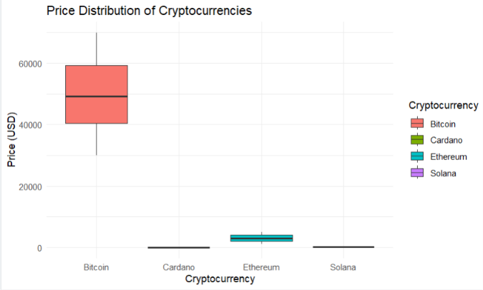

- Marathon Runner Performance Analysis

# Install package (Run only once)
# install.packages("ggplot2")

library(ggplot2)

# ------------------------------------------
# Create Sample Dataset
# ------------------------------------------

set.seed(123)

n <- 360

runner <- data.frame(
Direction = seq(0, 359, length.out = n),
Speed = runif(n, 8, 20), # km/h
HeartRate = runif(n, 90, 180), # bpm
Distance = cumsum(runif(n, 0.05, 0.2)),
Elevation = runif(n, 50, 250) # meters
)

# ==========================================
# Visualization 1: Cartesian Plot
# Speed vs Distance
# ==========================================

p1 <- ggplot(runner,
aes(x = Distance,
y = Speed,
color = Speed)) +
geom_line(size = 1) +
scale_color_gradient(
low = "blue",
high = "red"
) +
labs(
title = "Runner Speed vs Distance",
x = "Distance (km)",
y = "Speed (km/h)",
color = "Speed"
) +
theme_minimal()

print(p1)

# ==========================================
# Visualization 2: Heart Rate vs Distance
# ==========================================

p2 <- ggplot(runner,
aes(x = Distance,
y = HeartRate,
color = Speed)) +
geom_point(size = 2) +
scale_color_gradient(
low = "green",
high = "red"
) +
labs(
title = "Heart Rate During Marathon",
x = "Distance (km)",
y = "Heart Rate (bpm)",
color = "Speed"
) +
theme_minimal()

print(p2)

# ==========================================
# Visualization 3: Polar Plot
# Running Direction
# ==========================================

p3 <- ggplot(runner,
aes(x = factor(Direction),
y = Speed,
fill = Speed)) +
geom_bar(stat = "identity") +
coord_polar() +
scale_fill_gradient(
low = "lightblue",
high = "darkred"
) +
labs(
title = "Running Direction (Polar Plot)",
fill = "Speed"
) +
theme_minimal() +
theme(
axis.text.x = element_blank(),
axis.ticks = element_blank()
)

print(p3)

# ==========================================
# Visualization 4: Elevation vs Distance
# ==========================================

p4 <- ggplot(runner,
aes(x = Distance,
y = Elevation,
color = Speed)) +
geom_line(size = 1) +
scale_color_gradient(
low = "yellow",
high = "darkgreen"
) +
labs(
title = "Elevation Profile",
x = "Distance (km)",
y = "Elevation (m)",
color = "Speed"
) +
theme_minimal()

print(p4)

OUTPUT:
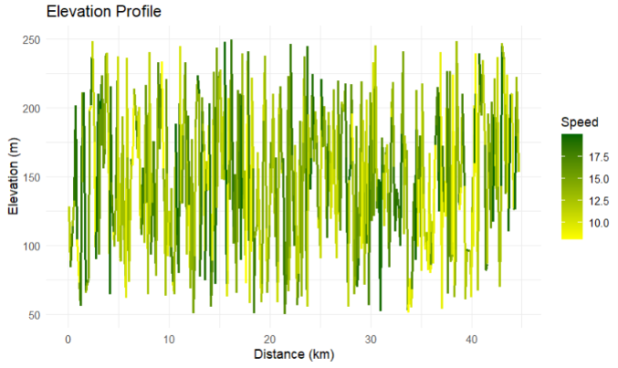

- COVID-19 Vaccination Campaign Dashboard

# Install package (Run only once)
# install.packages("ggplot2")

library(ggplot2)

# ------------------------------------------
# Create Sample Dataset
# ------------------------------------------

set.seed(123)

districts <- paste("District", 1:20)
age_groups <- c("18-30", "31-45", "46-60", "60+")
vaccines <- c("Covishield", "Covaxin", "Sputnik")

covid <- expand.grid(
District = districts,
AgeGroup = age_groups,
Vaccine = vaccines
)

covid$VaccinationRate <- sample(50:100, nrow(covid), replace = TRUE)

# ==========================================
# Dashboard Version 1
# Heatmap with Gradient Colors
# ==========================================

p1 <- ggplot(covid,
aes(x = AgeGroup,
y = District,
fill = VaccinationRate)) +
geom_tile(color = "white") +
scale_fill_gradient(
low = "lightyellow",
high = "darkgreen"
) +
labs(
title = "Vaccination Rate Heatmap",
x = "Age Group",
y = "District",
fill = "Vaccination %"
) +
theme_minimal()

print(p1)

# ==========================================
# Dashboard Version 2
# Bar Chart with Vaccine Type
# ==========================================

summary_data <- aggregate(VaccinationRate ~ Vaccine,
data = covid,
mean)

p2 <- ggplot(summary_data,
aes(x = Vaccine,
y = VaccinationRate,
fill = Vaccine)) +
geom_bar(stat = "identity") +
labs(
title = "Average Vaccination Rate by Vaccine Type",
x = "Vaccine",
y = "Average Vaccination (%)"
) +
theme_minimal()

print(p2)

# ==========================================
# Dashboard Version 3
# District-wise Vaccination
# ==========================================

district_data <- aggregate(VaccinationRate ~ District,
data = covid,
mean)

p3 <- ggplot(district_data,
aes(x = reorder(District, VaccinationRate),
y = VaccinationRate,
fill = VaccinationRate)) +
geom_bar(stat = "identity") +
coord_flip() +
scale_fill_gradient(
low = "orange",
high = "red"
) +
labs(
title = "District-wise Vaccination Rate",
x = "District",
y = "Average Vaccination (%)"
) +
theme_minimal()

print(p3)

# ==========================================
# Dashboard Version 4
# Age Group Comparison
# ==========================================

age_data <- aggregate(VaccinationRate ~ AgeGroup,
data = covid,
mean)

p4 <- ggplot(age_data,
aes(x = AgeGroup,
y = VaccinationRate,
fill = AgeGroup)) +
geom_bar(stat = "identity") +
labs(
title = "Vaccination by Age Group",
x = "Age Group",
y = "Average Vaccination (%)"
) +
theme_minimal()

print(p4)

OUTPUT:
